- Install nginx and run nginx on port number 81.
Input Steps :
---------------
1.Create a ec2 instance in aws account
2. Connect to the server with help of gitbash
3.sudo su (for switch user for root before it is ec2 )
4.yum install nginx
5. Systemctl start nginx
6.systemctl status nginx
7.systemctl enable nginx

Ssh -i “liunx test.pem” ec2-user@
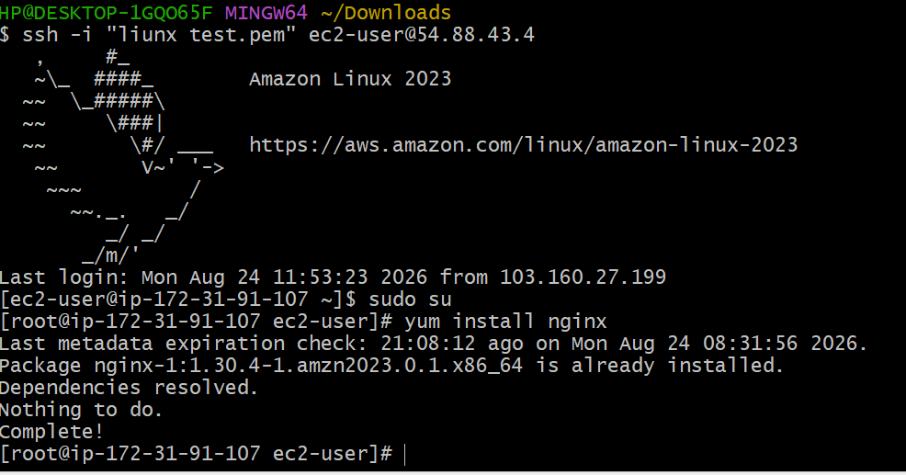
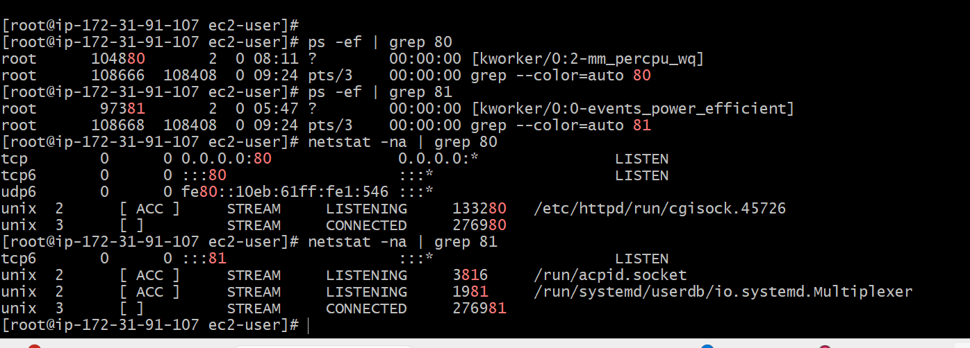

Open the configuration:
8. Cat /etc/nginx/nginx.conf —-read file
9. Vi /etc/nginx/nginx.conf —-edit file
Find the line:
listen 80;
Change it to:
listen 81;
Save and exit:
Esc → :wq → Enter
10. Test configuration using nginx -t
11. Systemctl restart nginx
12. Allow port 81 in AWS Security Group
In the EC2 Security Group, add an inbound rule:
Type: Custom TCP
Port: 81
Source:custom
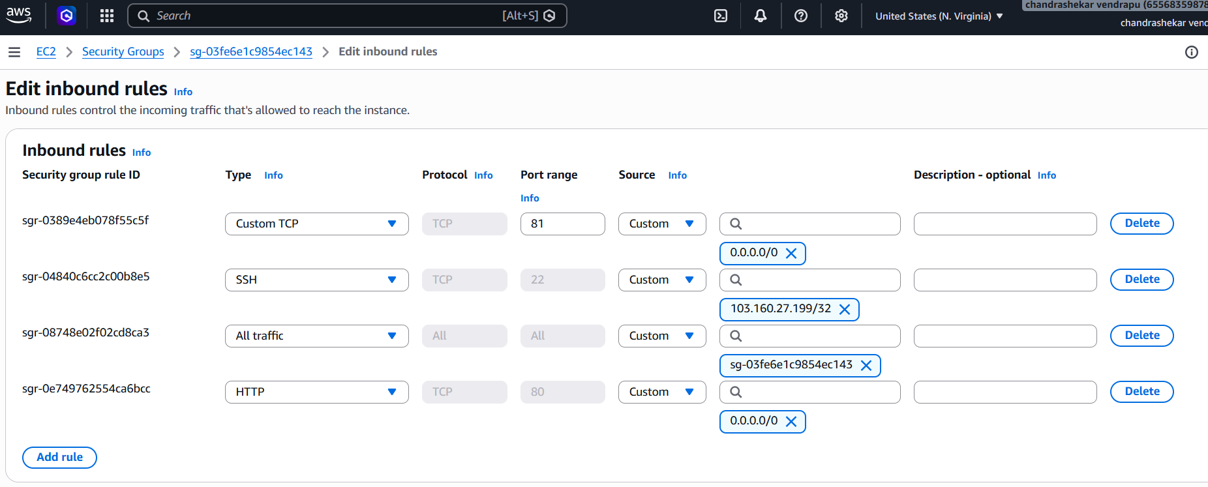
13. Access Nginx
In your Windows browser:
http://54.88.43.4:81/
You should see the Nginx welcome page.
output:



- Deploy a sample index.html file on nginx.
1. Check the Nginx web root
ls -l /usr/share/nginx/html/
2. Back up the existing index.html
mkdir -p /root/nginx-backup
cp /usr/share/nginx/html/index.html /root/nginx-backup/index.html
Verify:
ls -l /root/nginx-backup/
3. Create the sample index.html
vi /usr/share/nginx/html/index.html
Press i and enter:
<!DOCTYPE html>
<html>
<head>
<title>My Nginx Server</title>
</head>
<body>
<h1>Welcome to My Nginx Server</h1>
<p>Nginx is successfully running on port 81.</p>
</body>
</html>
Save:
Esc → :wq → Enter

4. Verify the HTML file
cat /usr/share/nginx/html/index.html
5. Test Nginx configuration
nginx -t
Expected:
syntax is ok
test is successful
6. Restart Nginx
systemctl restart nginx
7. Verify Nginx is running on port 81
ps -ef | grep 81
Or
netstat -na |grep 81

8. Test the deployed page using curl
curl http://localhost:81
The HTML content of the sample page should be displayed.
9. Access the page from the browser
From your Windows browser:
http://54.88.43.4:81
The browser should display:

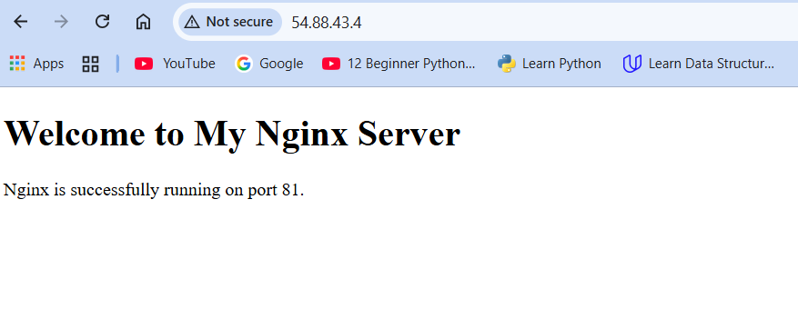
- Install Apache and run Apache on port number 82
On Amazon Linux/RHEL-based systems, the Apache package is called httpd.
1.yum install httpd -y

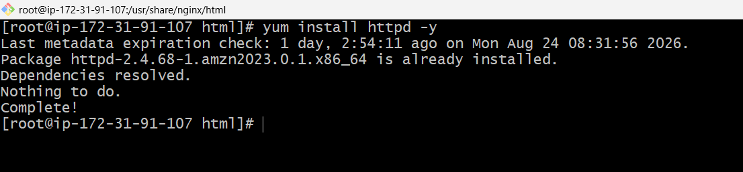
2. To check the Apache version httpd -v
3.systemctl start httpd
systemctl enable httpd
systemctl status httpd

3. Back up the Apache configuration
Create a backup directory:
mkdir -p /root/apache-backup
Back up the configuration:
cp /etc/httpd/conf/httpd.conf /root/apache-backup/httpd.conf
Verify:
ls -l /root/apache-backup/
4. Change Apache port from 80 to 82
Open the configuration:
vi /etc/httpd/conf/httpd.conf
Find:
Listen 80
Change it to:
Listen 82
Save and exit:
Esc → :wq → Enter
5. Test Apache configuration
httpd -t
Expected:
Syntax OK
6. Restart Apache
systemctl restart httpd
7. Check Apache status
systemctl status httpd
It should show:
Active: active (running)
8. Check Apache process
ps -ef | grep httpd
9. Verify port 82
netstat -na | grep 82
You should see Apache listening on port 82.
10. Test Apache using curl
curl http://localhost:82
You should receive the Apache default webpage HTML.
11. Test from the browser
Make sure TCP port 82 is allowed in your EC2 Security Group.
Then from your Windows browser:

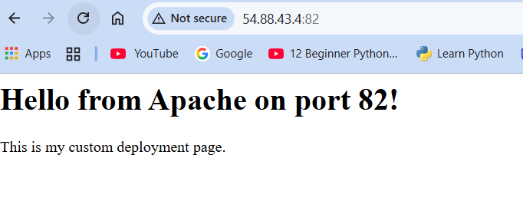

- Deploy a sample index.html file on Apache.
1. Check Apache web root
ls -la /var/www/html/
This is the standard Apache document root.
2. Back up the existing index.html
If an index.html already exists:
mkdir -p /root/apache-backup
cp /var/www/html/index.html /root/apache-backup/index.html
Verify:
ls -l /root/apache-backup/
3. Create the sample index.html
vi /var/www/html/index.html
Press i and enter:
<!DOCTYPE html>
<html>
<head>
<title>My Apache Server</title>
</head>
<body>
<h1>Welcome to My Apache Server</h1>
<p>Apache HTTP Server is successfully running on port 82.</p>
<p>This webpage is hosted on an AWS EC2 instance.</p>
</body>
</html>
Save and exit:
Esc → :wq → Enter
4. Verify the HTML file
cat /var/www/html/index.html
5. Test Apache configuration
Since only the HTML content was changed, the Apache configuration itself hasn't changed, but you can verify it:
httpd -t
Expected:
Syntax OK
6. Test the webpage using curl
Because Apache is configured for port 82:
curl http://localhost:82
You should see your new HTML content.
7. Access the webpage from Windows browser
Open:
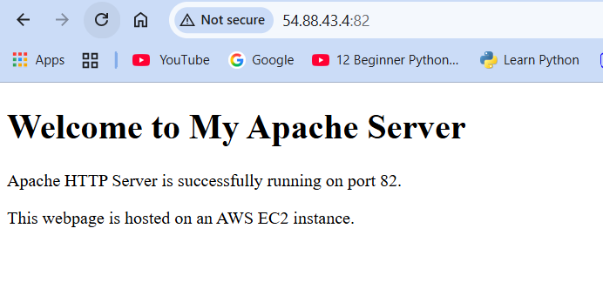
- Install Apache tomcat on port number 8082
Purpose
The purpose of this task is to understand how to:
- Install Java required for Tomcat.
- Download and extract Apache Tomcat.
- Locate Tomcat configuration files.
- Configure the Tomcat HTTP Connector to use port 8082.
- Start Tomcat using the built-in startup.sh script.
- Verify the Tomcat process and listening port.
- Test Tomcat using curl.
- Access the Tomcat welcome page from a web browser.
Implementation
1. Verify Java
java -version
If Java is not installed:
yum install java-17-amazon-corretto -y
Verify again:
java -version
2. Go to /root
cd /root
3. Download Apache Tomcat
wget https://archive.apache.org/dist/tomcat/tomcat-11/v11.0.24/bin/apache-tomcat-11.0.24.tar.gz
Verify the downloaded file:
ls -lh apache-tomcat-11.0.24.tar.gz
4. Extract Tomcat
tar -xzf apache-tomcat-11.0.24.tar.gz
Verify:
ls -ld apache-tomcat-11.0.24

5. Go to the Tomcat directory
cd /root/apache-tomcat-11.0.24
Check the files:
ls
Expected directories:
Bin conf lib logs temp webapps work
6. Check Tomcat connector port
grep 'Connector port' conf/server.xml
If it shows 8080, edit the configuration:
vi conf/server.xml
Find the HTTP Connector:
<Connector port="8080"
Change it to:
<Connector port="8082"
Save:
Esc → :wq → Enter
Verify:
grep 'Connector port' conf/server.xml
You should see the connector configured for 8082.
7. Start Tomcat
./bin/startup.sh
Expected:
Tomcat started.
8. Verify Tomcat process
ps -ef | grep tomcat
A Tomcat/Java process should be displayed.
9. Verify port 8082
ss -tlnp | grep :8082
Tomcat should be listening on port 8082.
10. Test using curl
curl http://localhost:8082
The Tomcat HTML response should be displayed.
12. Access Tomcat through browser
From your Windows browser:
http://54.88.43.4:8082/
The Tomcat welcome page should appear.
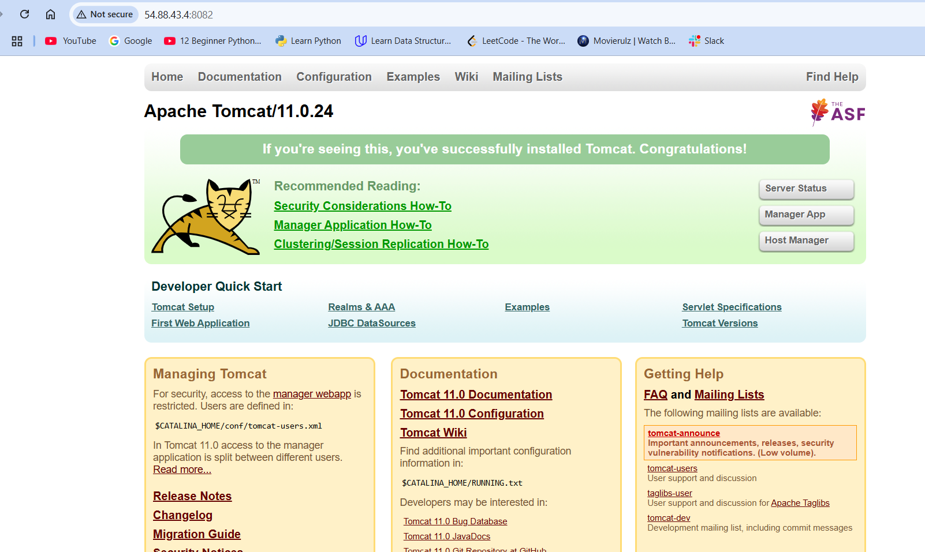

- Deploy a sample app on webapps
Purpose
To understand WAR-based application deployment in Tomcat and verify the application using the command line and web browser.
Implementation
1. Go to Tomcat webapps
cd /root/apache-tomcat-11.0.24/webapps
Check the directory:
ls -lh
2. Download the sample WAR
Use the Apache Tomcat sample application download:
wget https://tomcat.apache.org/tomcat-8.5-doc/appdev/sample/sample.war
Verify:
ls -lh sample.war
You should see:
sample.war
3. Check the WAR file
file sample.war
4. Start/restart Tomcat
Go back to the Tomcat directory:
cd /root/apache-tomcat-11.0.24
If Tomcat is already running, restart it:
./bin/shutdown.sh
Then:
./bin/startup.sh
Expected:
Tomcat started.
Tomcat automatically deploys WAR files placed in its webapps directory.
5. Verify deployment
ls -lh /root/apache-tomcat-11.0.24/webapps/
You should see:
sample.war
sample/
The sample/ directory is created automatically after Tomcat expands the WAR.
6. Check Tomcat process
ps -ef | grep tomcat
8. Test the application
Because your Tomcat is running on 8082:
curl http://localhost:8082/sample/
You should receive the sample application's HTML response.
9. Check deployment logs
tail -50 /root/apache-tomcat-11.0.24/logs/catalina.out
Look for deployment messages related to /sample.
10. Open in browser
From your Windows browser:
http://54.88.43.4:8082/sample/
You should see the Tomcat Sample Application.
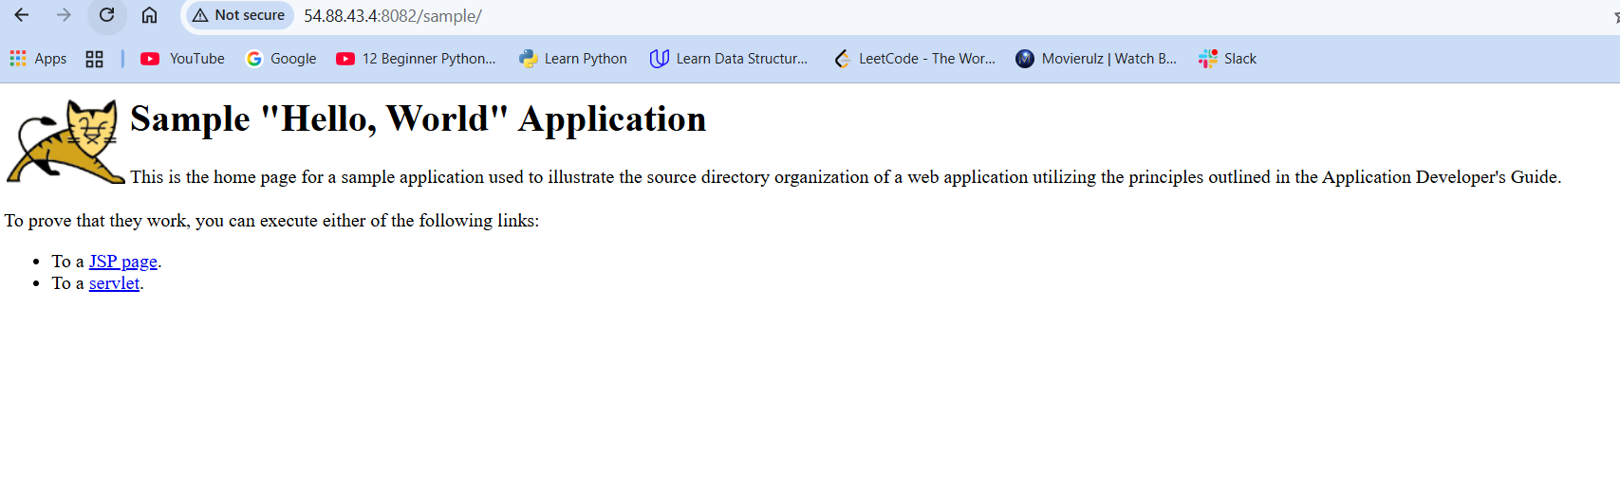
- Create a tomcat.service file for tomcat.
Purpose
The purpose of this task is to:
- Create a systemd service for Tomcat.
- Configure Tomcat to start automatically.
- Manage Tomcat using systemctl.
- Avoid manually running startup.sh and shutdown.sh.
- Verify that Tomcat is running correctly as a system service.
Implementation
1. Verify Tomcat location
cd /root/apache-tomcat-11.0.24
Check:
pwd
Expected:
/root/apache-tomcat-11.0.24
2. Find Java location
Run:
which java
Then:
readlink -f $(which java)
For example, it may show:
/usr/lib/jvm/java-17-amazon-corretto/bin/java
The JAVA_HOME will therefore be:
/usr/lib/jvm/java-17-amazon-corretto
3. Create the Tomcat service file
vi /etc/systemd/system/tomcat.service
Add:
[Unit]
Description=Apache Tomcat
After=network.target

[Service]
Type=forking

User=root
Group=root

Environment="JAVA_HOME=/usr/lib/jvm/java-17-amazon-corretto"
Environment="CATALINA_HOME=/root/apache-tomcat-11.0.24"
Environment="CATALINA_BASE=/root/apache-tomcat-11.0.24"

ExecStart=/root/apache-tomcat-11.0.24/bin/startup.sh
ExecStop=/root/apache-tomcat-11.0.24/bin/shutdown.sh

Restart=on-failure

[Install]
WantedBy=multi-user.target
Save:
Esc
:wq
Enter
Note: This matches your current lab setup where Tomcat is installed under /root/apache-tomcat-11.0.24 and you're running it as root. For production, Tomcat should normally run under a dedicated non-root user.
4. Reload systemd
systemctl daemon-reload
5. Enable Tomcat service
systemctl enable tomcat
This makes Tomcat start automatically when the server boots.
6. Start Tomcat using systemctl
systemctl start tomcat
7. Check service status
systemctl status tomcat
Expected:
Active: active (running)
8. Verify Tomcat process
ps -ef | grep tomcat
9. Verify port 8082
Since your Tomcat is configured on 8082:
ss -tlnp | grep :8082

10. Test using curl
curl http://localhost:8082
You should receive the Tomcat response.
11. Test service management
Stop:
systemctl stop tomcat
Check:
systemctl status tomcat
Start again:
systemctl start tomcat
Restart:
systemctl restart tomcat
Check:
systemctl status tomcat
output:

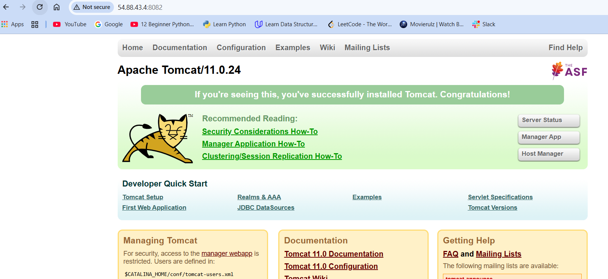
- Configure HA Proxy server
Run following command to Access the Server-1
• ssh -i your-key.pem ec2-user@Pubipaddress of Server-1 instance
• sudo -i
• yum update -y
• Yum install httpd -y
• Vi /etc/hosts
• Add HA-Proxy-Server Pubic IP Address
Run below command on Server-1
ping load_balancer -c 4
• systemctl start httpd
• systemctl status httpd
Browse with Server-1 Public IP address:80 it will work
Server-2 Steps:
Run following command to Access Server-2
• ssh -i your-key.pem ec2-user@Pubipaddress of Server-2 instance
• sudo -i
•whoami
• yum update -y

• yum install nginx -y
• sudo amazon-linux-extras install nginx1 -y

• vi /etc/hosts
• Add HA-Proxy-Server Pubic IP Address
Run below command on Server-2
ping load_balancer -c 4
• systemctl start nginx
• systemctl status nginx
Browse with Server-2 Public IP address:80 it will work
HA-Proxy-Server Steps:
Run following command to Access HA-Proy-Server
• ssh -i your-key.pem ec2-user@Pubipaddress of HA-Proxy-Server instance

• sudo -i
•whoami

• yum update -y
• yum install haproxy -y
• vi /etc/hosts
• Add Server-1, Server-2 Public IP’s

• vi /etc/haproxy/haproxy.cfg
• Add Server-1, Server-2 public IP’s
• systemctl enable haproxy
systemctl start haproxy
• systemctl status haproxy

• now browse with HA-Proxy-Server PublicIP:80 it will distribute load to Server-1, Server-2
